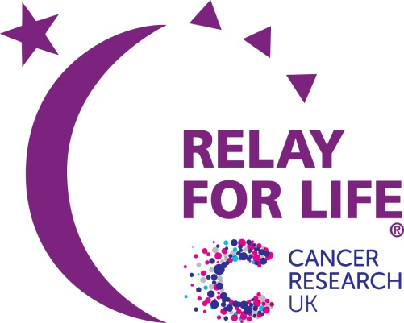

RELAY FOR LIFE, ASCOT – 21/22 July 2018 Theme: Back To School

December newsletter

Welcome to our first newsletter of the 2018 relay season! My name is Charlotte and I have taken over from Liz as your new Teams Chair for this year. My job is to provide you with all of the support you need when recruiting team members, fundraising, and getting the most out of your Relay For Life experience.

I will aim to circulate a newsletter like this every month, to share key information and give you some good fundraising tips and ideas. I would still really encourage at least one member of each team to come along to the face-to-face get-togethers, which are on the 2nd Wednesday of every month. If I haven’t met you already, I hope to do so in the very near future. In the meantime, if you have any comments or suggestions about this newsletter, or if you have any other questions or need any other support, please do get in touch – ascotrelayteamschair@outlook.com

THEME The 2018 theme is 'Back to School'. We can transform the Racecourse into a school fate, with food stalls, games such as hook a duck etc. Fancy dress ideas could include School of Rock, Harry Potter and so on…

TEAMS So far we have 13 teams registered. Welcome to Faith, Hope & Sarcasm, Frimley Hallstars, Gleeful Friends, Gleeful Friends 2, Lewis angels 2018, Michaela's Morphin Rangers, Mixed Bag of Nuts, Scholarly Steppers, Team Tate, The Crazy Kids, Walkie Talkies, Where's Widley Wallies, Whitley Karate Club.

YOUR 2018 PLANNING We still need to recruit more teams so if you know of anyone who is looking for a new challenge in 2018, let them know about Relay For Life. The sooner they register the sooner they can begin fundraising and planning for the event.

MEETING SCHEDULE We have planned a main topic for each of our teams meetings; the details are below. Our January meeting will concentrate on fundraising as we know how important this is to you. Also at the team night meetings, Dave the Accounts Chair will be there for you to bank any fundraising money.

SUCCESSES SO FAR As a result of Stand Up To Cancer Collections, the following teams raised; Faith, Hope & Sarcasm raised £670.11, Frimley Hallstars raised £217.53, Gleeful Friends 2 raised £68.49 and The Crazy Kids raised £102.77. Congratulations to all, keep up the hard work. Donations have also come in totalling over £250. Most recently we had the sale of Christmas Pin Badges by Faith, Hope & Sarcasm raising £28.70.

UPCOMING FUNDRAISERS There is an important fundraiser for World Cancer Day on 4th February 2018. Each registered team will be given a box of Unity bands to sell and have the opportunity to collect at Tesco’s or Waitrose stores we have secured for both February 3rd and 4th. Keep your eye on the Facebook group page for information!

YOUR EVENTS We always have banners, sweepstakes and other items at team meetings. You can use these to publicise any events that you may have, or simply to kick-start your own or your team fundraising.

DATES OF TEAMS MEETINGS Our teams meetings are on the second Wednesday of each month, plus an extra one in July. They will start at 7.30pm. All our meetings will have a main topic, but we will cover general items as well, and have the usual opportunities for you to ask questions or give us your news.

10th January – Fundraising
14th February – Candles of Hope
14th March – Survivors
11th April – Fundraising and Candles of Hope
9th May – Health Awareness and Candles of Hope
13th June – Logistics
11th July – Final Details

SAVE THE DATE!To celebrate reaching £1,000,000 raised for Cancer Research UK in our 10th year, Relay For Life Ascot are hosting ‘The Million Pound Ball’. Held at the Berystede Hotel in Ascot, tickets go on sale in the New Year. Please direct any queries to the Relay For Life Ascot. Facebook page. It is going to be such a special night!

